* + Significant - Categorical
  + Responsible - Categorical
  + Affiliation - Categorical
  + Age – Quantitative

* 1. Most respondents (over 70%) felt that the shutdown was significant

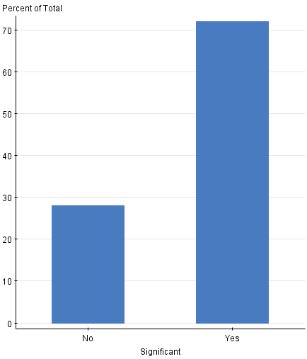

* 1. The majority of respondents either had no affiliation, or were affiliated themselves with Democrats. Only about a quarter (25%) identified as Republicans.

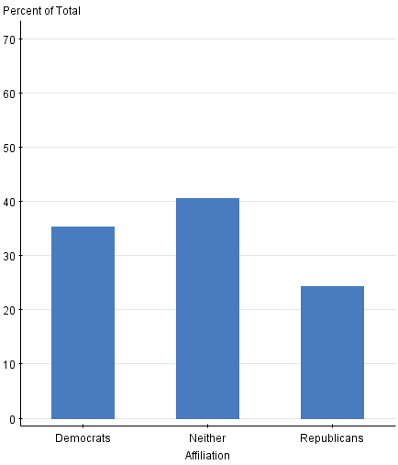

* 1. Over half of the respondents felt that both parties were to blame for the shutdown. Over three times as many people felt that the Republicans were more responsible for the shutdown than the Democrats.

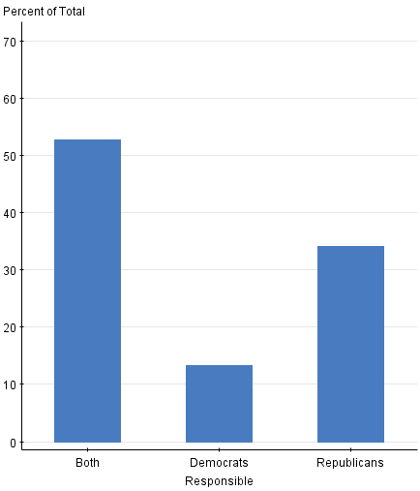

1. Significance across political affiliations plays an important role regarding the data. A larger percentage of Democrats believe that the shutdown was significant, while a larger portion of Republicans believed that the shutdown was not significant. People that identified under the “Neither” category were fairly equally split on the significance of the shutdown. When analyzing the significance based on each individual affiliation, all three affiliations believed that the shutdown was significant.

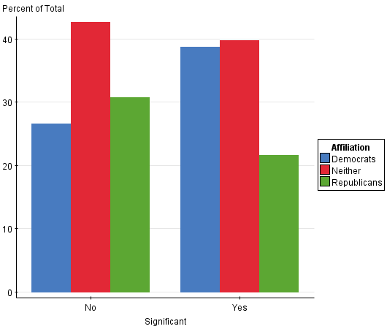 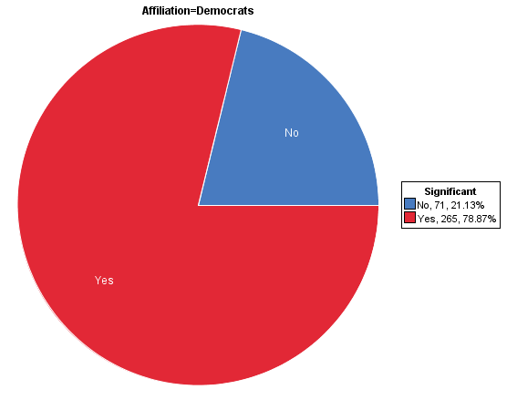 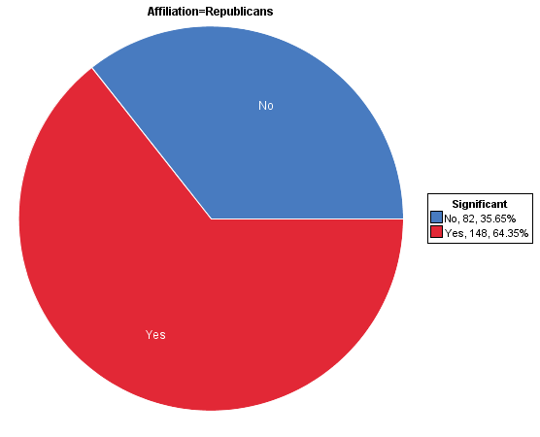 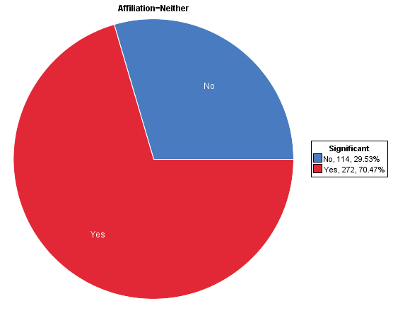

Most of the people that identified themselves as Republican tended to believe that Democrats were responsible for the shutdown, while people who identified as Democrats tended to believe that Republicans were most responsible for the shutdown. Almost 50% of people that identified as Neither believed that both parties were to blame.

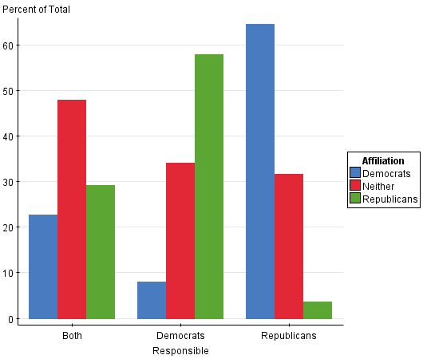

The pie charts do a better job at presenting the data for both questions, because it illustrates the total percentage of each class for the specific variable that is being analyzed. It is much easier to see the percentage of the whole on a pie chart, compared to a bar graph.

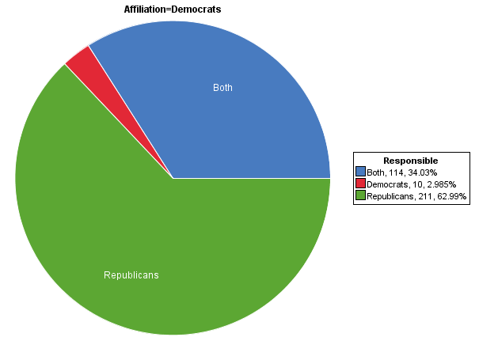

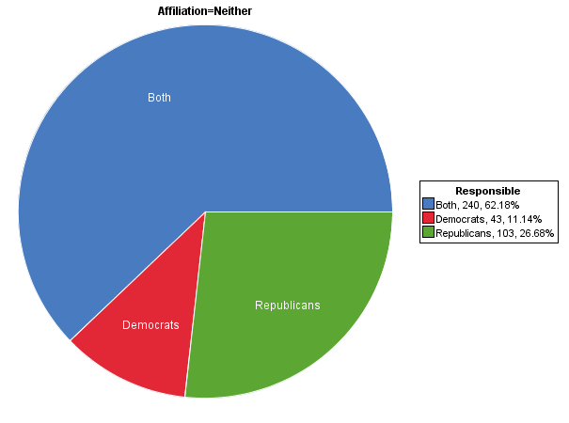 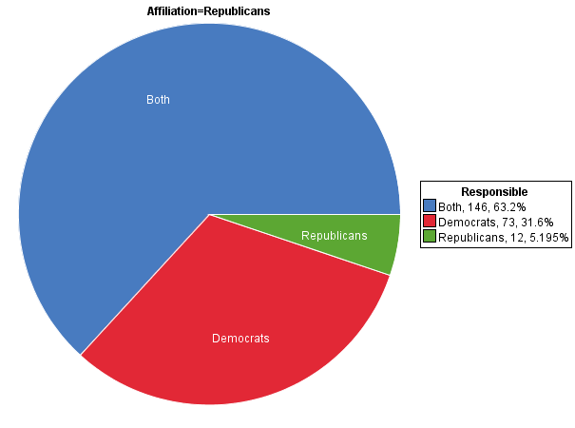

1. The min value of age is 10, while the max value of age is 100. The shape of the data is that of a bell curve, skewed to the right (there is a large concentration of data on the left). The median age is 25 years old ([959+1]/2 = 480. The 480th age in the set from smallest to largest is 25). The average age is 30.6 years old, so rounded up that is around 31 years old. The center of distribution is 25 years of going by the median, and 31 years old if going by the mean (since the graph is skewed right, mean > median). To measure the spread, I found the first and third quartiles. Q1 = 20, and Q3 = 40. The interquartile Range is 40 - 20 = 20. Thus the spread of data is approximately 20. This is a relatively large spread of data.

Noticeable outliers are ages in the 90s and in the 100s. The advantage of a steam and leaf plot for this data is that the shape gives a good idea about where the data is concentrated, and how it is spread out. A disadvantage of a steam and leaf plot for this data is that because there is a large amount of data, it can be tedious and difficult to look over, and difficult to find the median and mean to locate the spread and center of data.

1. Six classes are constructed, and the default binwidth is 20.

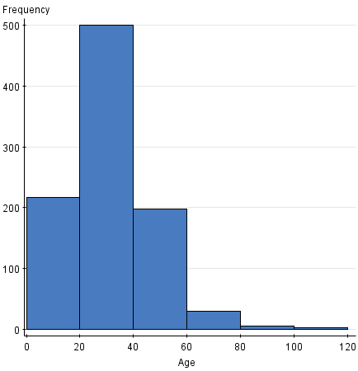

I chose a binwidth of 5 because it gives a good overview of the shape of the data, while still representing the outliers well. It is broad enough to give a nice representation of the data, while being specific enough to point out how many people were within a particular age group. It can be concluded from the histogram that the majority of people that participated in the study are between the ages of 15 and 40, which is where most of the data is concentrated. Issues that someone might want to take into consideration is that the data may be considered by some to be too specific, and thus doesn’t give a general overview of trends within the respective age groups. The shape, center, and spread of distribution is consistent with the data from the steam and leaf plot graph.

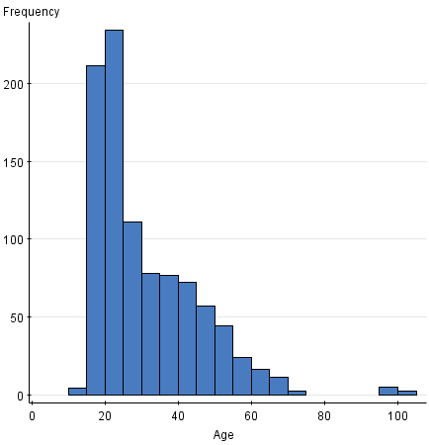

1. Age can seems to have some effect on the views the graph below illustrates certain trends. Between the ages of 10 and 40, the majority of people sampled believed that both parties were responsible for the shutdown, and a large amount of people believed that the Republicans were to blame. With the exception of people between the ages of 70-100, people over the age of 40 tend to be split pretty equally between believing that Republicans and that both parties were responsible.

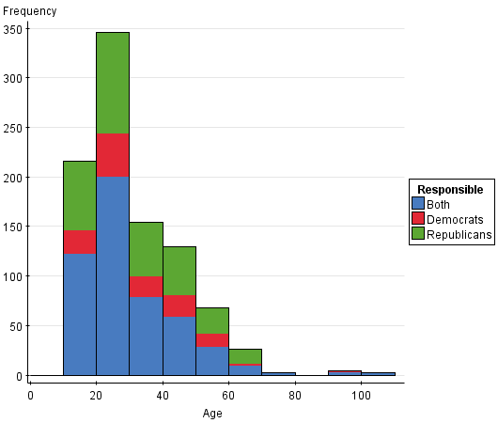

As age increases, a larger portion of people tend to believe that that the shutdown was significant. The frequency of people that believe that it is significant seems to increase with age, excluding the outliers.

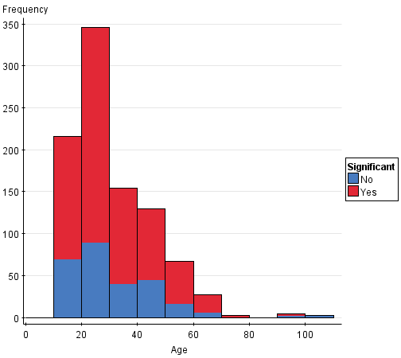

Finally, the graph below illustrates that as people grow older, they generally tend to have a more concrete political affiliation. A large frequency of 20-40 year olds fall under the “Neither” category, but more 40+ year olds identify themselves as either Democracts or Republicans. It is interesting to note that after 30 years of age, the proporiton of people that identify themselves as Republican shrank considerably.

